
Sukkur Institute of Business Administration University Department of Computer Science

Object oriented programming in Java BS – II Spring-2025

Lab # 02
Java Essentials Lab: Exploring type conversion, String and Control Structures

Instructor: Nimra Mughal
Section BSCS Ai-B
Submitted By: Azhar Ali Soomro
CMS: 023-24-0521

Exercises
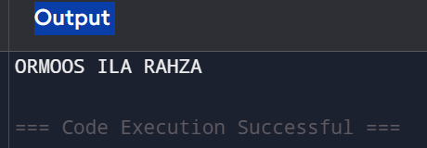
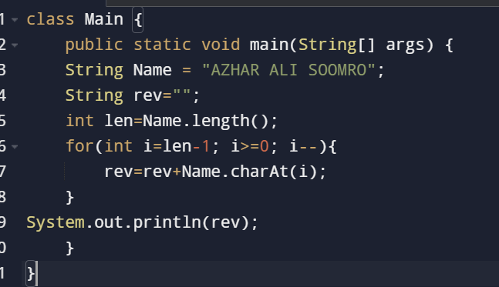
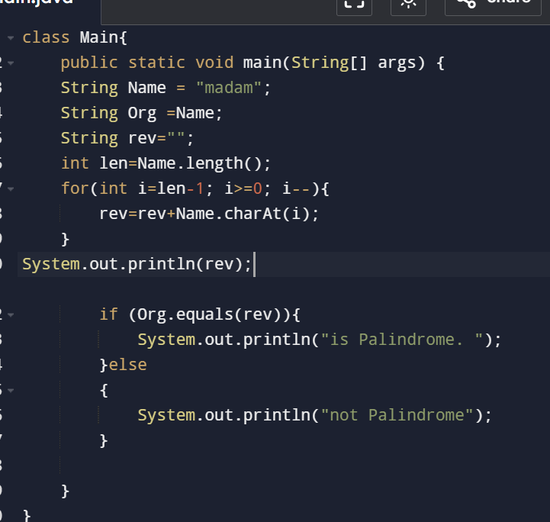
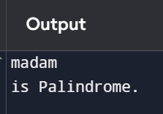
1. Reverse a string: Write a method that reverses the characters of a given string.
Code:
Output:
2. Check for palindromes: Write a method that determines whether a string is a palindrome (reads the same backward as forward).
CODE:
3. Remove duplicate characters: Write a method that removes duplicate characters from a string, preserving the order of unique characters.
CODE:
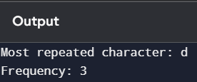
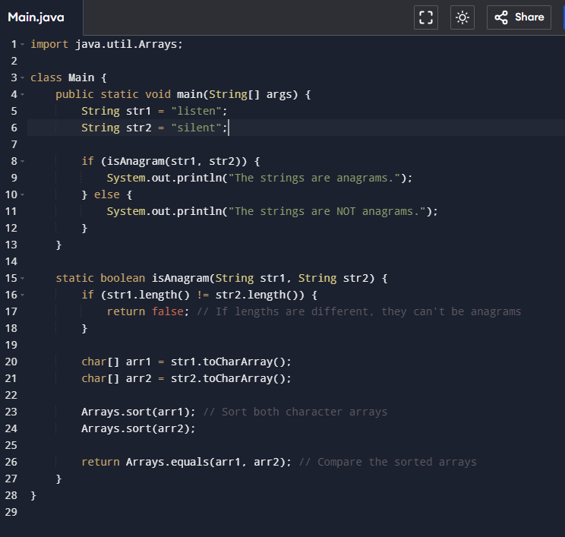
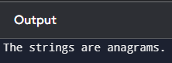
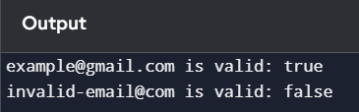
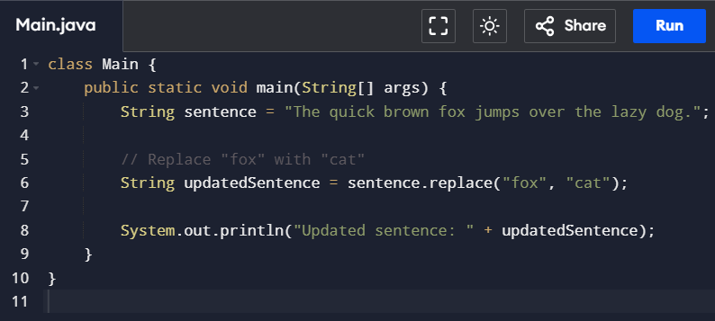
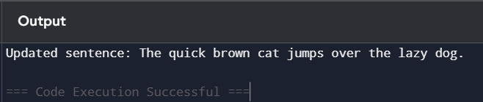
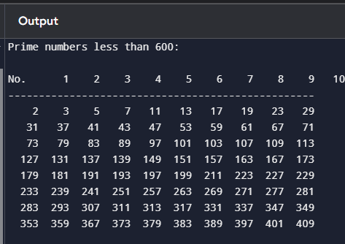
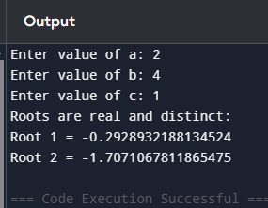
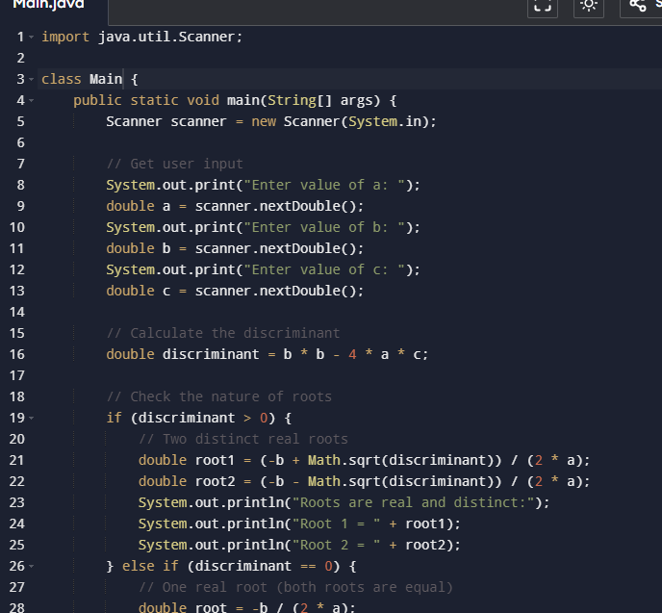
4. Find the most frequent character: Write a method that finds the character that appears most frequently in a string.
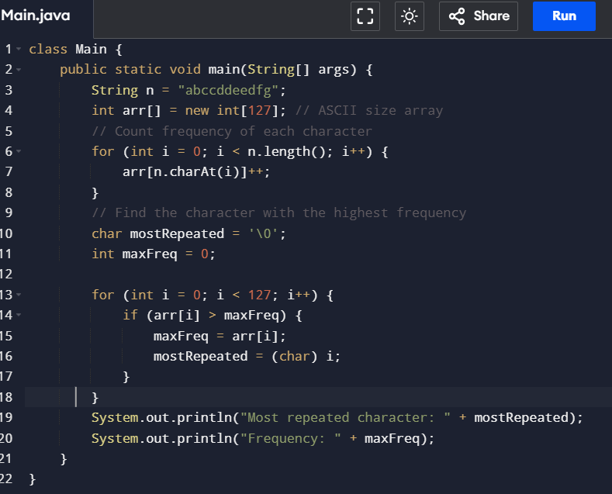
5. Check for anagrams: Write a method that determines whether two strings are anagrams (have the same characters in different arrangements).
6. Validate email addresses: Write a method that checks whether a given string is a valid email address.
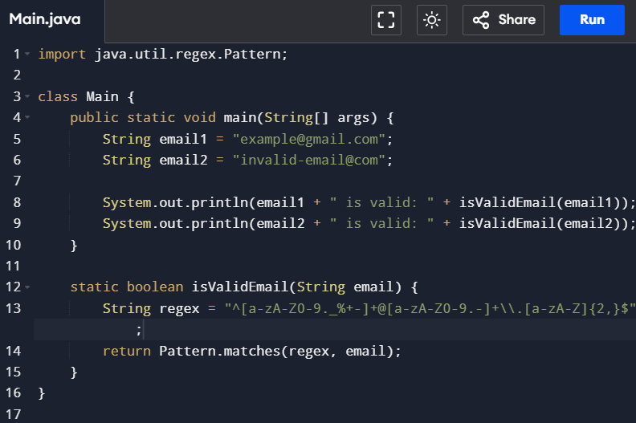
7. Write a Java program to replace each substring of below given sample string
a. Sample string: "The quick brown fox jumps over the lazy dog."
b. In the above string replace all the fox with cat
8. Write a program to print prime number less than 600 and print out the numbers in table format on cmd.
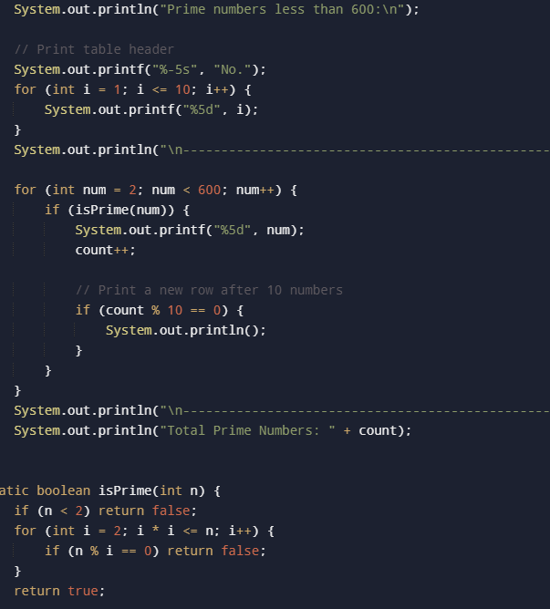
9. Write a program which solves quadratic equations of the form: ax2 + bx + c = 0. Values of a, b, c can be taken as input from user.

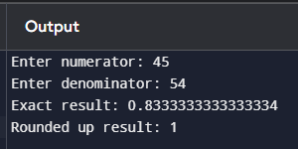
10. Write a Java program to round up the result of variable division
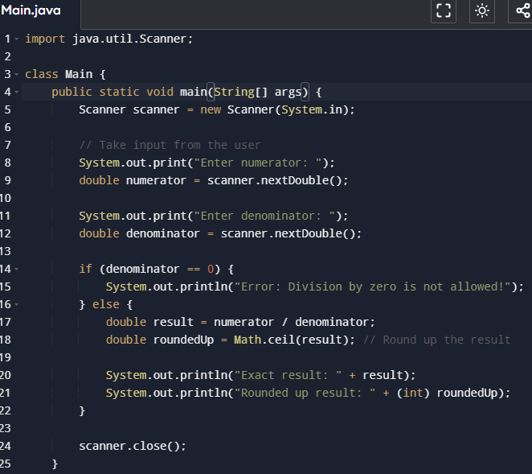
THE END

